PIZZA SALES SQL QUERIES
- KPI’s

- Total Revenue:
SELECT SUM(total_price) AS TOTAL_REVENUE FROM pizza_sales

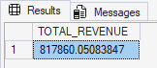

- Average order value
SELECT SUM(total_price) / COUNT(DISTINCT order_id) AS AVERAGE_ORDER_VALUE FROM pizza_sales

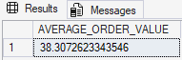
- Total pizzas sold
SELECT SUM(quantity) AS Total_pizzas_sold FROM pizza_sales

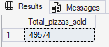

- Total Orders
SELECT COUNT(DISTINCT order_id) AS Total_order FROM pizza_sales

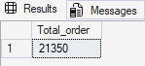
- Average Pizzas Per Order
SELECT CAST(CAST(SUM(quantity) AS decimal(10,2)) / CAST(COUNT(DISTINCT order_id) AS decimal(10,2)) AS decimal(10,2))
AS total_pizzas_per_order FROM pizza_sales

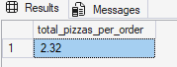

- DAILY TREND FOR TOTAL ORDERS
SELECT * FROM pizza_sale
SELECT DATENAME(DW,order_date) as Order_day, COUNT(DISTINCT order_id) as
Total_orders
from pizza_sales
Group by DATENAME(DW, order_date)

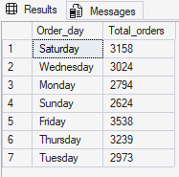

- PERCENTAGE OF SALES BY PIZZA CATEGORY

NOTE

If you want to apply the Month,Quarter,Week filters to the above
Queries you can use WHERE clause. Follow some of below examples
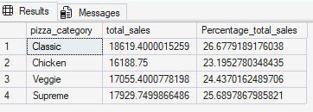
*Here where MONTH(order_date) = 1 indicates the percentage of total sales in the month JANUARY.
where MONTH(order_date) = 4 indicates the percentage of total sales in the month APRIL.

SELECT DATENAME(DW, order_date) AS order_day, COUNT(DISTINCT order_id) AS
total_orders
FROM pizza_sales
WHERE DATEPART(QUARTER, order_date) = 1
GROUP BY DATENAME(DW, order_date)
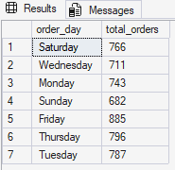
*Here DATEPART(QUARTER, order_date) = 1 indicates the output is for quarter 1
DATEPART(QUARTER, order_date) = 3 indicates the output is for the quarter 3

- PERCENTAGE OF SALES BY PIZZA SIZE

SELECT pizza_size,SUM(total_price) as total_sales, SUM(total_price) * 100 / (SELECT SUM(total_price) FROM pizza_sales WHERE DATEPART(QUARTER, order_date) = 1 ) as Percentage_total_sales
from pizza_sales
WHERE DATEPART(QUARTER, order_date) = 1
GROUP BY pizza_size
order by Percentage_total_sales desc

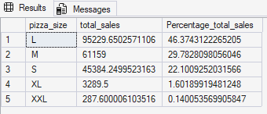

- TOTAL PIZZAS SOLD BY PIZZA CATEGORY

SELECT pizza_category, sum(quantity) As Total_pizza_sold
from pizza_sales
group by pizza_category
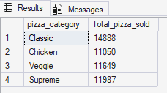

- TOP 5 BESTSELLERS BY TOTAL PIZZAS SOLD

SELECT top 5 pizza_name, SUM(quantity) as Total_pizzas_sold
from pizza_sales
group by pizza_name
order by Total_pizzas_sold desc
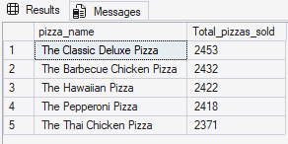

- Bottom 5 WORST SELLER BY TOTAL PIZZAS SOLD

SELECT top 5 pizza_name, SUM(quantity) as Total_pizzas_sold
from pizza_sales
group by pizza_name
order by Total_pizzas_sold ASC

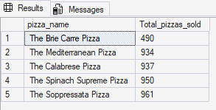

- HOURLY TREND OF PIZZA SALES

